# DATABASE SYSTEM PRACTICUM REPORT

# MODULE 4 s

**DATA DEFINITION LANGUAGE**



**CREATED BY :**

**KURNIAWAN BAGASKARA**

**L200214253**

# INFORMATICS STUDY PROGRAM

**FACULTY OF COMMUNICATION AND INFORMATION SCIENCE MUHAMMADIYAH SURAKARTA UNIVERSITY**

Data in module 2 :

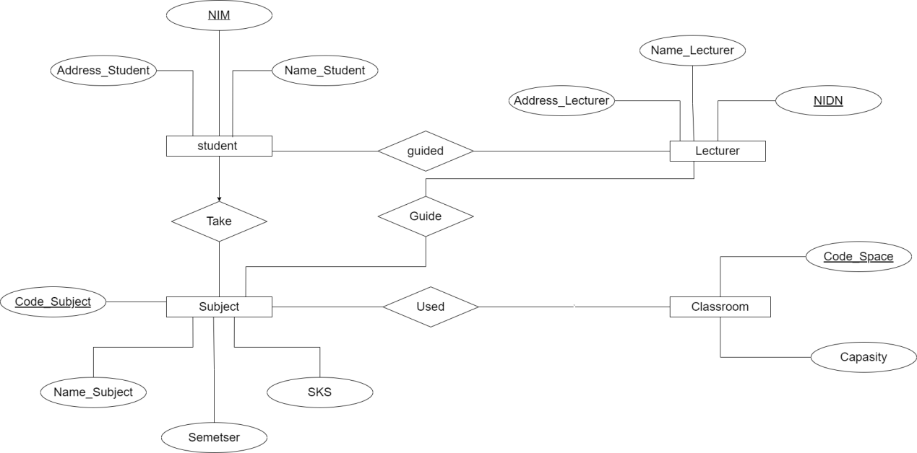

Open Cmd login MySQL

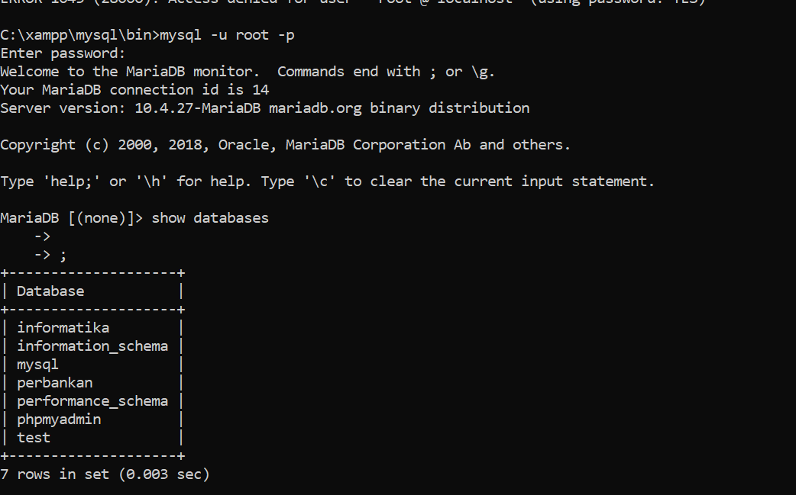

Create data base Kuliah

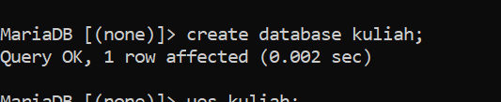

Use data base



Create Table Mahasiswa

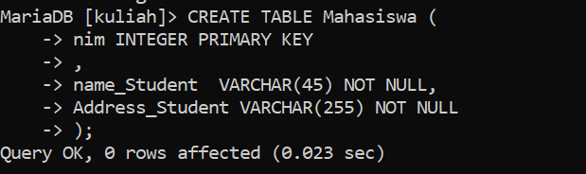

Create Table Lecturer

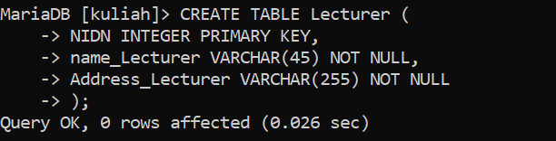

Create Table Classroom

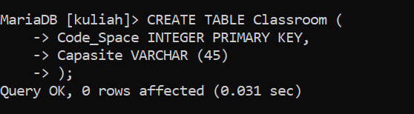

Create Table Subject

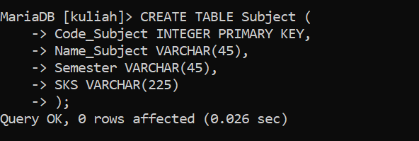

Table Mahasiswa

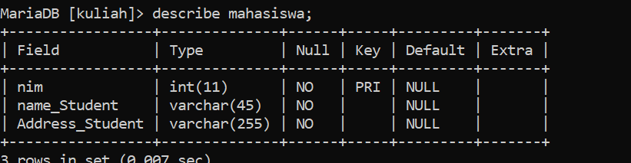

Table Lecturer

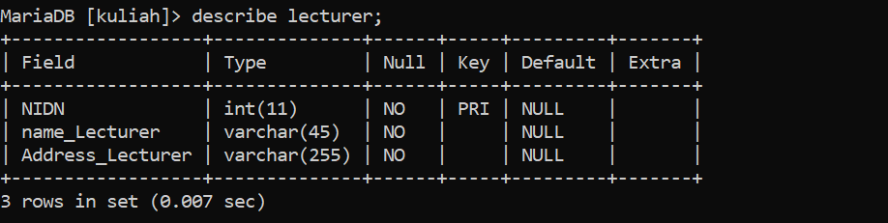

Table Classroom

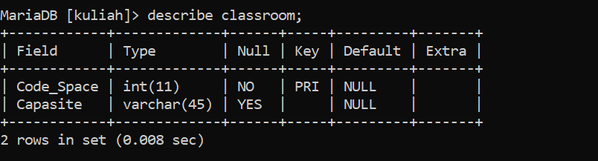

Table Subject

